# Week 1

* Structured thinking: Structured thinking is the process of recognizing the current problem or situation, organizing available information, revealing gaps and opportunities, and identifying the options.
* Problem types:

1. making predictions (using data to make an informed decision about how things may be in the future),
2. categorizing things (assigning information to different groups or clusters based on common features),
3. spotting something unusual (identifying data that is different from the norm),
4. identifying themes (grouping categorized information into broader concepts),
5. discovering connections (finding similar challenges faced by different entities and combining data and insights to address theme), and
6. finding patterns, using historical data to understand what happened in the past and is therefore likely to happen again

* SMART methodology: specific, measurable, action-oriented, relevant and time –bound.

1. Specific questions are simple, significant, and focused on a single topic or a few closely related ideas.
2. Measurable question can be quantified and assessed.
3. Action-oriented questions encourage changes.
4. Relevant questions matter, are important, and have significance to the problem you’re trying to solve

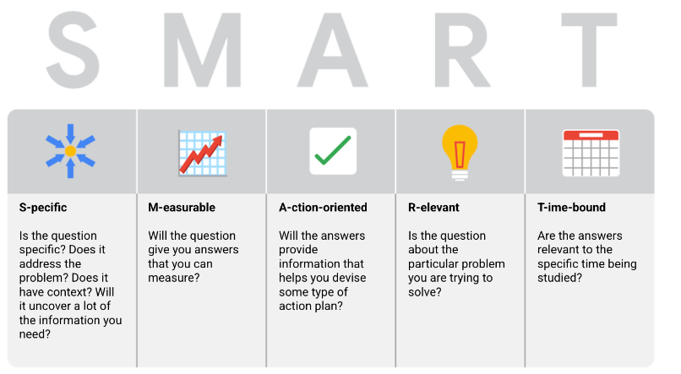

# Week 2

* Data-inspired decision making: explores different data sources to find out what they have in common
* Algorithm: a process or set of rules to be followed for a specific task
* Quantitative data: specific and objective measures of numerical facts (the what, how many, how many)
* qualitative data describes subjective or explanatory measures of qualities and characteristics or things that can't be measured with numerical data, like your hair color
* Report: static collection of data given to stakeholders periodically

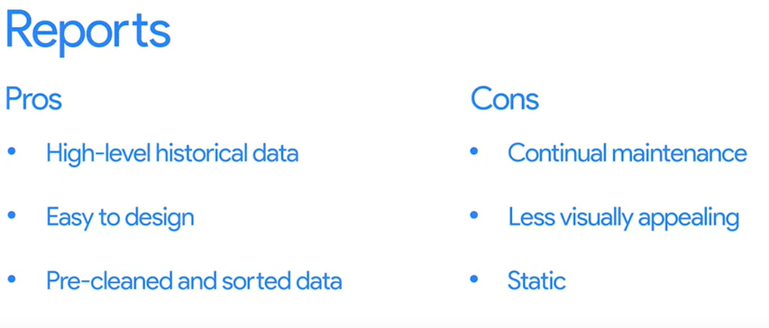

* Dashboard: monitors live, incoming data.

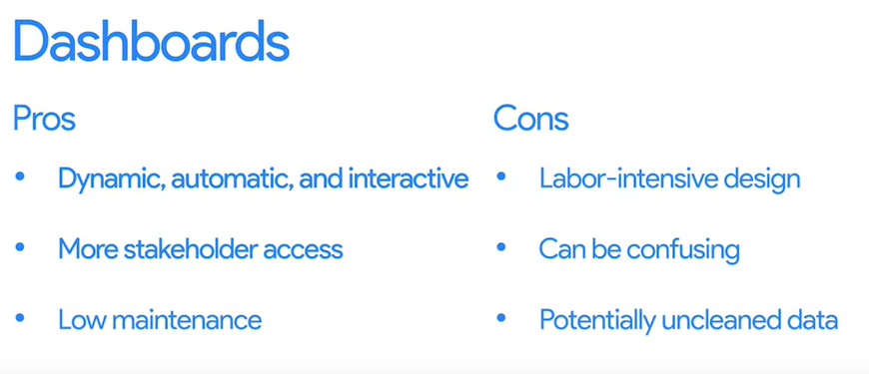

* A pivot table is a data summarization tool that is used in data processing. Pivot tables are used to summarize, sort, re-organize, group, count, total, or average data stored in a database. It allows its users to transform columns into rows and rows into columns.
* Metric: single, quantifiable type of data that can be used for measurement
* 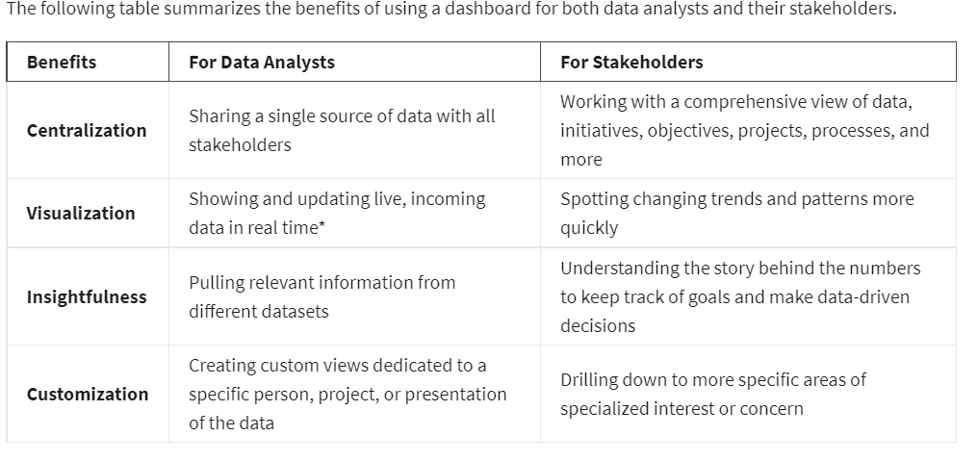
* 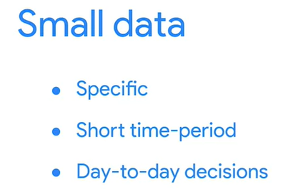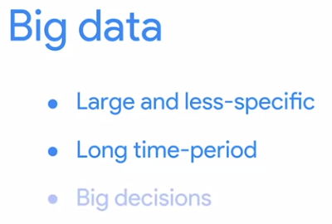
* 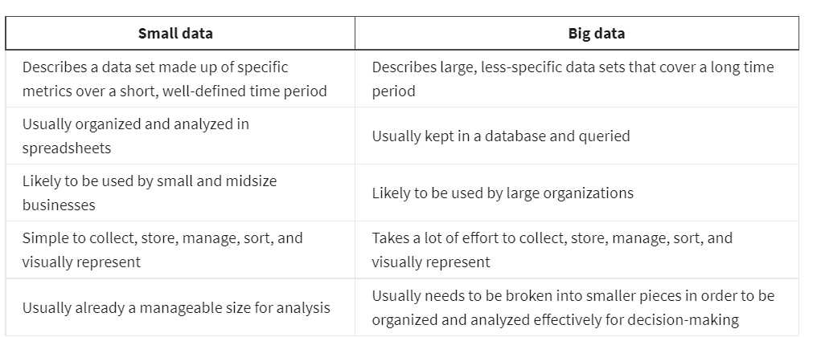
* 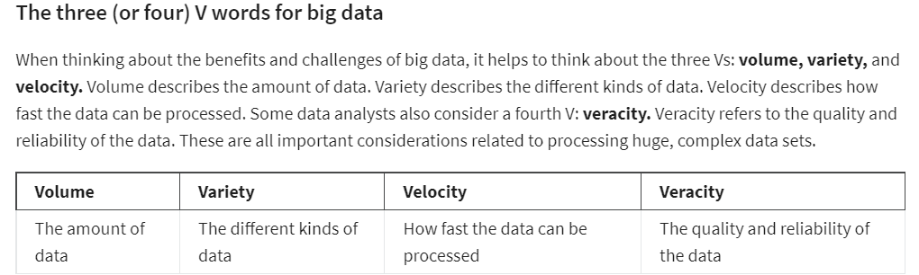

# Week 3

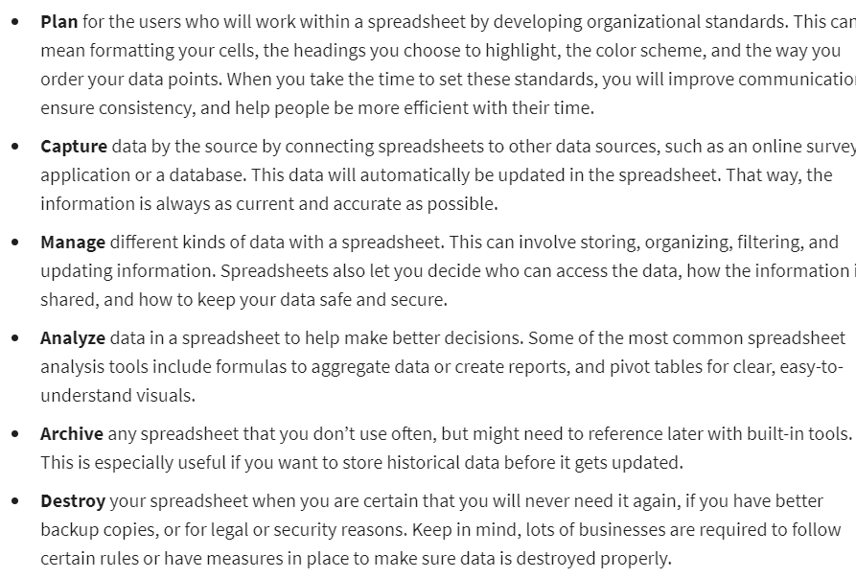

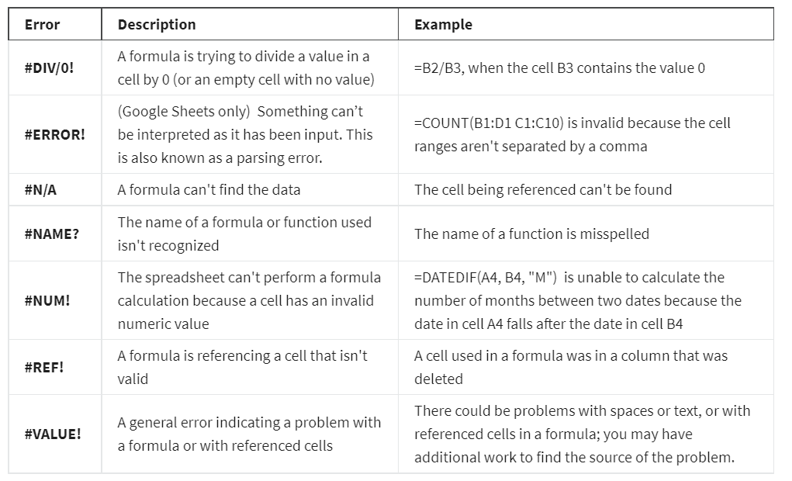

* Structured thinking: the process of recognizing the current problem or situation, organizing available information, revealing gaps and opportunities, and identifying the options.
* A scope of work or SOW is an agreed- upon outline of the work you're going to perform on a project
* A statement of work is a document that clearly identifies the products and services a vendor or contractor will provide to an organization. It includes objectives, guidelines, deliverables, schedule, and costs.
* What is a good SOW?

1. Deliverables: What work is being done, and what things are being created as a result of this project? When the project is complete, what are you expected to deliver to the stakeholders? Be specific here. Will you collect data for this project? How much, or for how long?
2. Milestones: This is closely related to your timeline. What are the major milestones for progress in your project? How do you know when a given part of the project is considered complete?
3. Timeline: Your timeline will be closely tied to the milestones you create for your project. The timeline is a way of mapping expectations for how long each step of the process should take. The timeline should be specific enough to help all involved decide if a project is on schedule. When will the deliverables be completed? How long do you expect the project will take to complete?
4. Reports: Good SOWs also set boundaries for how and when you’ll give status updates to stakeholders. How will you communicate progress with stakeholders and sponsors, and how often? Will progress be reported weekly? Monthly? When milestones are completed? What information will status reports contain?

* Context is the condition in which something exists or happens.

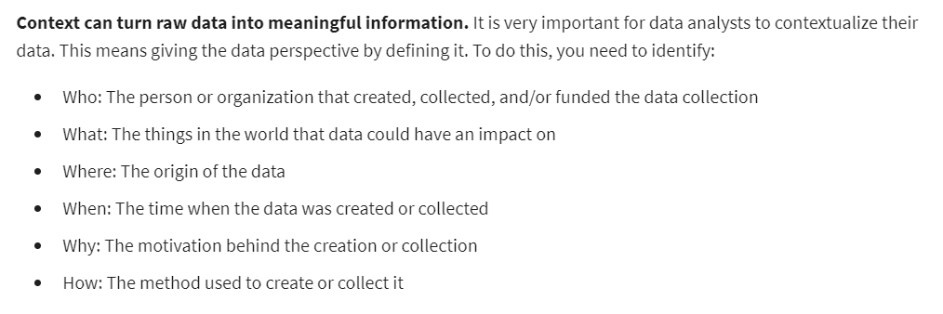

# Week 4

* Stakeholders: people that have invested time, interest, and resources into the projects you’ll be working on as a data analyst.
* there are three common stakeholder groups that you might find yourself working with: the executive team, the customer-facing team, and the data science team

1. The executive team provides strategic and operational leadership to the company. They set goals, develop strategy, and make sure that strategy is executed effectively. The executive team might include vice presidents, the chief marketing officer, and senior-level professionals who help plan and direct the company’s work.
2. The customer-facing team includes anyone in an organization who has some level of interaction with customers and potential customers. Typically they compile information, set expectations, and communicate customer feedback to other parts of the internal organization. These stakeholders have their own objectives and may come to you with specific asks.
3. Data science team

* Focus on what matters

1. Who are the primary and secondary stakeholders
2. Who is managing the data
3. Where can you go for help

* 